CIDER 2012: Deep Time
Impacts Tutorial Handout
July 16, 2012
Sarah T. Stewart, sstewart@eps.harvard.edu

Motivating Questions:
What does the Earth remember from accretion?
How did the Earth grow? How long did it take?
What was the thermal state of the planet during accretion?
What interesting things happened during planet formation related to impacts (e.g., moon formation, chemical differentiation)?

Goals:
Overview of the role of impacts during planet formation.
A sense of the state of the art in the field (numerical and lab experiments).
Identification of some open issues and points of contention.

Some jargon:
Giant impact stage of planet formation: The final chaotic stage following the oligarchic stage.
Giant impacts: Not precisely defined. Commonly used to mean impacts between similarly sized bodies where the 3D aspect of the event is critical [Asphaug, 2010].
Basin-forming impacts: Large cratering events. Historical definition is >300 km diameter craters on the Moon. The transition to basins from smaller complex craters is most easily identified in a depth to diameter plot, which shows a change in slope [e.g., Williams and Zuber, 1998] that is likely related to the larger amount of melt production influencing crater collapse mechanics at the basin-scale [STS].
Planetesimals: Notional original solid building blocks of planets. 1-km size bodies are commonly used to initialize simulations of the runaway/oligarchic growth phase.
Protoplanets: Approximately equivalent to oligarchs.
Oligarchs: Protoplanets that dominate a radial feeding zone and are separately widely enough to that dynamical friction by planetesimals maintains circular orbits. The mass of oligarchs is determined by the isolation mass (lunar to Mars mass bodies at 1 AU).
Planets: See IAU 2006

Part I: How did the Earth grow?
Standard Terrestrial Planet Formation [Chambers, 2010; Morbidelli et al., 2012]
- Dust to planetesimals (~1km)
  - Fast, poorly understood [Cuzzi et al., 2008; Johansen et al., 2007]
- Planetesimals to protoplanets
  - Runaway growth of (randomly) largest bodies by gravitational focusing. Accrete Moon to Mars size bodies in 10⁵-10⁶ yrs at 1 AU.
  - Oligarchic growth of largest bodies when single large body dominates a radial zone of the disk. Each oligarch grows faster than the surrounding planetesimals but more slowly than the runaway growth phase until each reaches an isolation mass. Oligarchs maintain a separation of ~10 Hill Radii. Bimodal size distribution (oligarchs and planetesimals). Around 1 AU, typical isolation masses are 0.01 to 0.1 M_{Earth}.
  - Dynamical friction from the smaller bodies keeps orbits circular and inhibits collisions between the largest bodies.
  - This stage is modeled using statistical calculations where size distributions of bodies in discrete radial bins interact with each other.
- Stochastic growth=Giant impact stage.
  - Onset of giant impact phase when mass in planetesimals < mass in oligarchs. Then the mass in the planetesimals does not supply enough dynamical friction to prevent gravitational interactions between the oligarchs. [Kenyon and Bromley, 2006]
  - The final planets are very dependent on initial conditions. Typically last 100-200 Myr. Planets accrete material from a wider range of radial distances. [Agnor et al., 1999; O'Brien et al., 2006; Raymond et al., 2009]
  - The models can make Venus and Earth-like planets. The models do not consistently make Mars and Mercury (Mars too large; Mercury not attempted).
  - Giant impacts are hypothesized to produce odd features in the planets: Mercury’s large core fraction, Venus retrograde rotation, Earth’s moon, Mars crustal dichotomy, Pluto system, Haumea system
  - Calculations in this phase are done by N-body codes that are extremely computationally intensive and not parallelizable (N² with time).
  - Note that each study begins with a different radial zone in the solar system, different numbers of planetary embryos (which roughly correspond to variations in the start time of the simulation), and different number of planetesimals. All have similar surface density of solids with distance from the Sun. Older models began with all the mass in embryos. Newer models begin with embryos+planetesimals to mimic the end of oligarchy. Because of computational limitations, the planetesimals are ‘non-interacting’ (embryo particles interacted gravitationally with all other bodies but planetesimal particles do not interact with each other).
  - Almost all N-body simulations assume perfect merging when two bodies collide. This is a poor assumption but an analytic description of collision outcomes has only recently become available [Leinhardt and Stewart, 2012].

The 3 stages are modeled with different codes. There are some artificial aspects introduced by the separation in computing different stages (e.g., not all the oligarchs are fully formed at the same time as implied at the start of N-body simulations). Newest codes are hybrid statistical/N-body codes that will be able to directly model the transition from runaway growth to final planets [Bromley and Kenyon, 2006; 2011; Levison et al., 2005; Morishima et al., 2010; Morishima et al., 2008].

Nice model (Giant planet outward migration)
The core of the Nice model (named after the Nice Observatory in France) is the idea that the 4 giant planets were originally closer to the Sun in a very compact configuration at the time the nebular gases dispersed. Exterior to the giant planets was a massive disk of planetesimals. Slowly, the giant planets scattered the planetesimals inward and the giant planets migrated outward. In the original model, Jupiter and Saturn eventually are captured into the 2:1 mean motion resonance. The resonance increases the eccentricity of both planets, leading to strong gravitational perturbations of the orbits of Uranus and Neptune and the planetesimal disk. The giant planets rapidly migrate out to their current positions (with nonzero eccentricities and inclinations) and scatter out most of the small bodies in the outer solar system. [Tsiganis et al., 2005]
The original model proposed that the timing of the migration of the giant planets coincided with the observed spike in basin-forming impacts on the Moon (and inferred to be throughout the inner solar system) at about 3.9 Ga (known as the Late Heavy Bombardment or the Lunar Cataclysm). The properties of the planetesimal disk exterior to the giant planets were tweaked to delay outward migration. [Gomes et al., 2005]
The Nice model has been expanded to try to explain many other features related to the dynamical architecture of the Solar System.
The motions of the giant planets have a profound effect on the accretion of rocky/icy planets in the inner and outer solar system.

The core idea that the giant planets migrated significant distance outward is widely accepted. Ancillary aspects of the model (such as timing to the LHB) are under continued debate.

Recent additions to the Nice Model:
E-belt and the extended late heavy bombardment
(Aside: the late heavy bombardment is not a continuous extension of primary accretion of the terrestrial planets; there must have been a hiatus in collisions before the onset of the event around 3.9 Ga [Bottke et al., 2005].)
The inner asteroid belt (called the E-belt) was probably more extended toward Mars than the present day. Clearing of the E-belt during giant planet migration led to a more prolonged period of basin-forming impact events on the Earth than previously thought. [Bottke et al., 2012].
(Aside: if you are interested in whether or not these basin-forming impact sterilized the surface of the Earth, recent work suggests that life could survive [Abramov and Mojzsis, 2009])

Grand Tack and the formation of Mars
Standard terrestrial planet formation simulations yield a planet between the Earth and the asteroid belt that is more massive than Mars.
[Hansen, 2009] suggested that a Mars size planet would form if the feeding zone for the 4 terrestrial planets was truncated (by some unknown mechanism) to between 0.7 and 1 AU.
[Walsh et al., 2011] propose that Jupiter migrated inward from gas-driven migration (during the presence of the nebular gas) and then migrated outward again by being caught in a mean motion resonance with Saturn. The inward then outward migration of Jupiter (the Grand Tack) scatters planetesimals outside of 1 AU, leaving the terrestrial planets to form in the truncated annulus. Then, the normal Nice model outward migration of the giant planets happens as in the standard Nice model.
See movies of the process here:
http://www.obs.u-bordeaux1.fr/e3arths/raymond/movies_grandtack.html
In the Grand Tack model, Mercury and Mars form by being scattered out of the annulus. Mars is essentially an ejected planetary embryo with a fast accretion time scale (~Myr).
The M(t) function for Earth can be very different in the Grand Tack model compared to the standard model. There may be no, few, or several giant impacts.

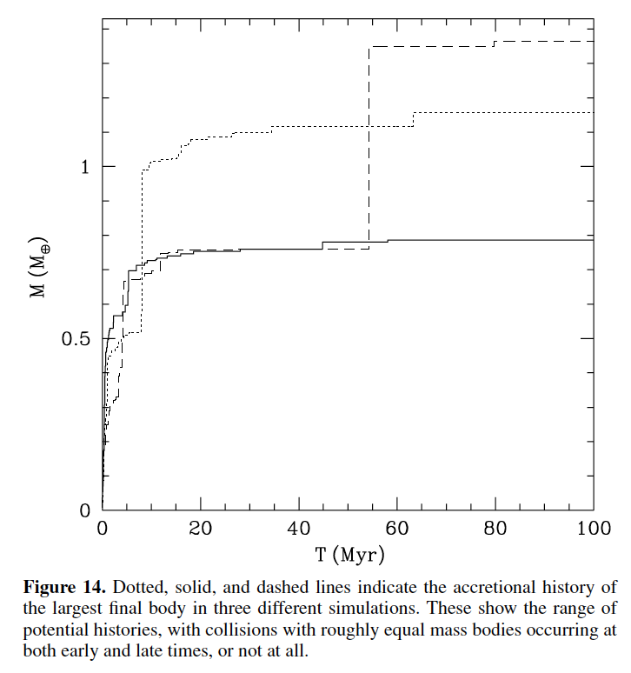
Figure from [Hansen, 2009].

Part II: Aspects of giant impacts and planet formation
How efficient was terrestrial planet formation?

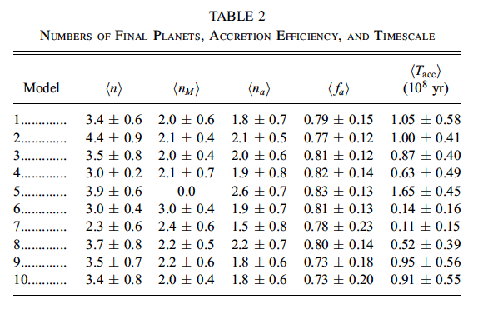
Table from [Kokubo et al., 2006] who modeled formation of planets between 0.5 and 1.5 AU starting with about 12-35 initial embryos (no planetesimals) with a total mass of about 2.3 Mearth. <n> is number of final planets >0.5 Mearth, <nM> is number between 0.5 to 1.5 AU, <fa> is accretion efficiency between 0.5 to 1.5 AU, <Tacc> is time of accretion.
In this case, about 80% of the embryos initially between 0.5 and 1.5 AU ended up in planets in the same radial distance (some ended up in planets outside this range, some in the Sun, some lost from system).

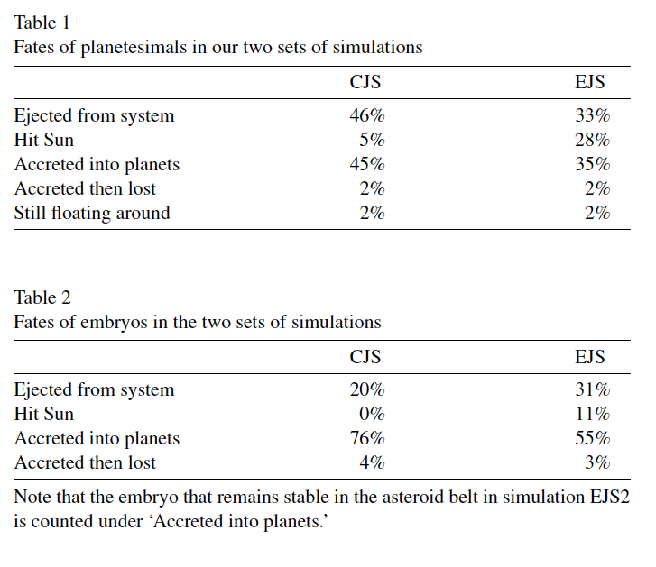
Table from [O'Brien et al., 2006] who simulated accretion between 0.3 and 4 AU (4.7 Mearth total mass; 2.6 Mearth inside 2 AU) starting with 25 Mars-size embryos and 1000 planetesimals (14 embryos and ~550 planetesimals within 2 AU). CJS=circular orbits for Jupiter and Saturn; EJS= eccentric orbits.
The accretion efficiency depends on the dynamics of the giant planets and differs between planetesimals and embryos.

How long did planet formation take?
Typically estimated by a model Hf/W age for core formation [Jacobsen, 2003; Jacobsen, 2005; Kleine et al., 2009].
Timescales for planet growth from N-body models is dependent on the model initial conditions. Typically ~100 Myr (but tweaked to match the age of the moon, which is currently in debate and estimated 30-100 Myr).
Very fast formation of Mars, 1-3 Myr [Dauphas and Pourmand, 2011]: a planetary embryo; formed before nebular gases dispersed (Mars has solar noble gas composition – SM); and probably formed a magma ocean from radioactive heating.

What are the dynamical outcomes of giant impacts?
By this, I mean, how much material is accreted during giant impacts? What are the velocity and size distributions of the debris?

Giant impact outcomes are divided into distinct categories [Leinhardt and Stewart, 2012; Stewart and Leinhardt, 2012]:
- Perfect merging
- Graze-and-merge
- Hit-and-run
- Partial accretion
- Partial erosion
- Super-catastrophic (disruption)

For typical planet formation, giant impact outcomes are approximately evenly divided between partial accretion, hit-and-run, and graze-and-merge [Stewart and Leinhardt, 2012]. Collision outcomes may be calculated in an online java app:
http://www.fas.harvard.edu/~planets/sstewart/resources/collision/

As noted above, almost all N-body simulations assume perfect merging. This is a poor assumption. So what?
- The deposition of shock and accretional energy is different in each category impact event.
- For the standard planet formation models, significant amounts of debris (15-20% of the final planet mass) is created during giant (and planetesimal) impacts [Genda et al., 2011; Stewart and Leinhardt, 2012]. Debris is created by eroding the smaller body in partial accretion and hit-and-run events. Some of the debris will re-impact the planet later but some could be lost by dynamical interactions with other bodies or, if the debris has a small enough size, lost via Poynting-Robertson drag. The accretion efficiency statistics above suggests that not all of the material will be reaccreted.
- The dynamical feedback of impact-generated debris on the overall growth of planets is not yet known (requires use of hybrid accretion models and will be computationally intensive) as there are competing factors.

Is collisional erosion important for the composition of the Earth?
We don’t know yet.

[O'Neill and Palme, 2008] proposed that collisional erosion in giant impacts (they were thinking hit-and-run, but that does not remove much material from the larger body) could explain an enhancement in bulk Fe/Mg over solar and depletion of refractory lithophile elements.
If all the debris is not all re-accreted, then it is possible to enhance the core/mantle mass ratio in the largest bodies by collisional erosion [SL2012].
Collision models have not yet directly addressed the issue of erosion of the crust. This is a work in progress by different groups. It may be possible that the cumulative affects of lost crust are important [but many caveats…..]

[Asphaug, 2010] proposed that erosion of the smaller body in hit-and-run events can lead to interesting compositions (mantle stripping, volatile stripping) and diversity among planets. Standard growth of the Earth would involve several hit-and-run events where the (stripped/devolatilized) embryo would eventually be accreted; this process could affect the volatile budget of the final planet [SL2012].

What is the thermal state of the Earth during accretion? How much melts during giant impacts?
Giant impacts have enough energy to form deep magma oceans [Melosh, 1990; Tonks and Melosh, 1993].
The total amount of melting for an individual impact is under debate. The numerical models of individual giant impact events are still very simple and neglect important processes (strength, enthalpy of melting).

Planet accretion preferentially deposits energy in outer layers. The thermal state of the Earth during accretion and immediately after is sensitive to M(t), which depends on the specifics of the overall dynamics of the solar system, and the ‘healing processes’ [DJS] between giant impacts. Time scales for magma ocean freezing is short enough (<5 Myr) [Elkins-Tanton, 2008] that the planet may solidify between giant impacts.

Moon-forming impacts generate nearly to possibly complete melting and a silicate atmosphere. Most vaporized material is bound and will recondense (timescale of ~1000 yr [DJS]).

Several groups are now addressing the thermodynamics of giant impacts. Shock wave data (equation of state information) can be obtained on planetary materials for the entire range of interest. For example, the Sandia Z-machine can launch flyer plates up to 40 km/s (the end stage of planet formation has typical impact velocities of 10 to 30 km/s). Shock-induced vaporization has been achieved on laser platforms [Kraus et al., 2012; Kurosawa et al., 2012] and are in progress at the Z-machine.

We need improved equations of state (EOS) models to be able to calculate the amount of melting during giant impacts. E.g., current models assume a pure forsterite mantle. We need both experiments and theories to build EOS models over the vast pressure-temperature space encountered during planet accretion.

Part III: Some open questions
1. Chemical mixing during giant impacts
Is the Earth remixed chemically after each giant impact (or after the last one)?

Recent isotope data from the deep mantle indicate that some material from earlier stages of accretion was not fully mixed with material from later stages of accretion [Mukhopadhyay, 2012]. And W isotopes suggest long term preservation of early mantle differentiation [Touboul et al., 2012].

Thus, the data demonstrate that there was not perfect mixing of the whole mantle during planet accretion [to be discussed in the Geochemistry tutorials]. Giant impacts were imperfect mixing events. The time-dependent process of accretion must be considered to explain the geochemical data (rather than thinking of giant impacts are ‘resetting’ events.)

2. Core equilibration and the Hf-W system
Does the merging iron core chemically equilibrate with mantle? [Dahl and Stevenson, 2010] The problem needs more work on the breakup of cores for different size impactors and for different category impact events.

3. The origin of the Moon
The giant impact hypothesis is widely accepted for the origin of the Moon. The details of the impact origin are under debate because of recent high-precision measurements that indicate that the Earth and Moon are isotopically identical (O, W, Ti, Cr) [Lugmair and Shukolyukov, 1998; Touboul et al., 2007; Wiechert et al., 2001; Zhang et al., 2012] [Si and Nd are also similar but more controversial].

In the canonical giant impact model [Canup, 2004; 2008; Canup and Asphaug, 2001], a Mars-size impactor obliquely hits the proto-Earth near the escape velocity. In this case, the majority (60-80 wt%) of the moon-forming disk is derived from the impactor. Because the impactor is expected to have a distinct isotopic signature, the moon should not have the same isotopes as the Earth.

[Pahlevan and Stevenson, 2007] proposed post-impact isotopic equilibration between the Earth and lunar disk. [Reufer et al., 2011] propose special impactor conditions (e.g., large icy body in a hit-and-run event). [Salmon and Canup, 2012] propose a multi-stage formation for the Moon where the inner portion of the Moon has an isotopic signature of the projectile and the material in the outer part of the Moon had equilibrated with Earth. [Cuk and Stewart, 2012] propose that the lunar disk formed by impact-induced fission (explaining the compositional similarity) and that the present day angular momentum was achieved by a resonance between the lunar orbit and the Sun [see online talk from last week].

So, there is much debate and the origin of the moon is not a solved problem.

Postscript
Apologies for missing references. Let me know about them and this handout will be amended on the CIDER web site.

References

Abramov, O., and S. J. Mojzsis (2009), Microbial habitability of the Hadean Earth during the late heavy bombardment, Nature, 459(7245), 419-422.
Agnor, C. B., R. M. Canup, and H. F. Levison (1999), On the character and consequences of large impacts in the late stage of terrestrial planet formation, Icarus, 142(1), 219-237.
Asphaug, E. (2010), Similar-sized collisions and the diversity of planets, Chemie der Erde, 70, 199-219.
Bottke, W. F., D. D. Durda, D. Nesvorny, R. Jedicke, A. Morbidelli, D. Vokrouhlicky, and H. Levison (2005), The fossilized size distribution of the main asteroid belt, Icarus, 175(1), 111-140.
Bottke, W. F., D. Vokrouhlicky, D. Minton, D. Nesvorny, A. Morbidelli, R. Brasser, B. Simonson, and H. F. Levison (2012), An Archaean heavy bombardment from a destabilized extension of the asteroid belt, Nature, 485(7396), 78-81.
Bromley, B. C., and S. J. Kenyon (2006), A hybrid N-body-coagulation code for planet formation, Astron. J., 131(5), 2737-2748.
Bromley, B. C., and S. J. Kenyon (2011), A New Hybrid N-body-coagulation Code for the Formation of Gas Giant Planets, The Astrophysical Journal, 731(2), 101.
Canup, R. M. (2004), Simulations of a late lunar-forming impact, Icarus, 168(2), 433-456.
Canup, R. M. (2008), Lunar-forming collisions with pre-impact rotation, Icarus, 196(2), 518-538.
Canup, R. M., and E. Asphaug (2001), Origin of the Moon in a giant impact near the end of the Earth's formation, Nature, 412(6848), 708-712.
Chambers, J. (2010), Terrestrial Planet Formation, in Exoplanets, edited by S. Seager, p. 23, U. Arizona Press.
Cuk, M., and S. T. Stewart (2012), Making the Moon from a fast-spinning Earth: A giant impact followed by resonant despinning, Science, submitted.
Cuzzi, J. N., R. C. Hogan, and K. Shariff (2008), Toward Planetesimals: Dense chondrule clumps in the protoplanetary nebula, The Astrophysical Journal 687(2), 1432-1447.
Dahl, T. W., and D. J. Stevenson (2010), Turbulent mixing of metal and silicate during planet accretion — And interpretation of the Hf–W chronometer, Earth Planet. Sci. Lett., 295(1–2), 177-186.
Dauphas, N., and A. Pourmand (2011), Hf-W-Th evidence for rapid growth of Mars and its status as a planetary embryo, Nature, 473(7348), 489-492.
Elkins-Tanton, L. T. (2008), Linked magma ocean solidification and atmospheric growth for Earth and Mars, Earth Planet. Sci. Lett., 271(1-4), 181-191.
Genda, H., E. Kokubo, and S. Ida (2011), Giant Impacts and Terrestrial Planet Formation, Lunar & Planet. Sci. Conf., 42, Abs. 2090.
Gomes, R., H. F. Levison, K. Tsiganis, and A. Morbidelli (2005), Origin of the cataclysmic Late Heavy Bombardment period of the terrestrial planets, Nature, 435(7041), 466-469.
Hansen, B. M. S. (2009), Formation of the Terrestrial Planets from a Narrow Annulus, The Astrophysical Journal, 703(1), 1131.
Jacobsen, S. B. (2003), How Old Is Planet Earth?, Science, 300(5625), 1513-1514.
Jacobsen, S. B. (2005), The Hf-W isotopic system and the origin of the Earth and Moon, Annu. Rev. Earth Planet. Sci., 33, 531-570.
Johansen, A., J. S. Oishi, M. M. Mac Low, H. Klahr, and T. Henning (2007), Rapid planetesimal formation in turbulent circumstellar disks, Nature, 448(7157), 1022-1025.
Kenyon, S. J., and B. C. Bromley (2006), Terrestrial planet formation. I. The transition from oligarchic growth to chaotic growth, Astron. J., 131(3), 1837-1850.
Kleine, T., M. Touboul, B. Bourdon, F. Nimmo, K. Mezger, H. Palme, S. B. Jacobsen, Q. Z. Yin, and A. N. Halliday (2009), Hf-W chronology of the accretion and early evolution of asteroids and terrestrial planets, Geochim. Cosmochim. Acta, 73(17), 5150-5188.
Kokubo, E., J. Kominami, and S. Ida (2006), Formation of terrestrial planets from protoplanets. I. Statistics of basic dynamical properties, Astrophys. J., 642(2), 1131-1139.
Kraus, R. G., S. T. Stewart, D. C. Swift, C. A. Bolme, R. Smith, S. Hamel, B. Hammel, D. K. Spaulding, D. G. Hicks, J. H. Eggert, and G. W. Collins (2012), Shock vaporization of silica and the thermodynamics of planetary impact events, J. Geophysical Research -- Planets, submitted. Preprint available at http://www.people.fas.harvard.edu/~rkraus.
Kurosawa, K., T. Kadono, S. Sugita, K. Shigemori, T. Sakaiya, Y. Hironaka, N. Ozaki, A. Shiroshita, Y. Cho, S. Tachibana, T. Vinci, S. Ohno, R. Kodama, and T. Matsui (2012), Shock-induced silicate vaporization: The role of electrons, J. Geophys. Res., 117(E4), E04007.
Leinhardt, Z. M., and S. T. Stewart (2012), Collisions between Gravity-Dominated Bodies: I. Outcome Regimes and Scaling Laws, Astrophys. J., 745, 79 (27pp).
Levison, H., D. Nesvorny, C. Agnor, and A. Morbidelli (2005), The Role of Dynamical Friction in Terrestrial Planet Formation, 37th DPS Meeting, Abs. 25.01.
Lugmair, G. W., and A. Shukolyukov (1998), Early solar system timescales according to 53Mn-53Cr systematics - Ibitira, Geochim. Cosmochim. Acta, 62(16), 2863-2886.
Melosh, H. J. (1990), Giant impacts and the thermal state of the early Earth, in Origin of the Earth, edited by H. E. Newsom and J. H. Jones, pp. 69-83, Oxford U. Press, New York.
Morbidelli, A., J. I. Lunine, D. P. O'Brien, S. N. Raymond, and K. J. Walsh (2012), Building Terrestrial Planets, Annu. Rev. Earth Planet. Sci., 40(1), 251-275.
Morishima, R., J. Stadel, and B. Moore (2010), From planetesimals to terrestrial planets: N-body simulations including the effects of nebular gas and giant planets, Icarus, 207(2), 517-535.
Morishima, R., M. W. Schmidt, J. Stadel, and B. Moore (2008), Formation and Accretion History of Terrestrial Planets from Runaway Growth through to Late Time: Implications for Orbital Eccentricity, The Astrophysical Journal, 685(2), 1247.
Mukhopadhyay, S. (2012), Early differentiation and volatile accretion recorded in deep-mantle neon and xenon, Nature, 486(7401), 101-104.
O'Brien, D. P., A. Morbidelli, and H. F. Levison (2006), Terrestrial planet formation with strong dynamical friction, Icarus, 184(1), 39-58.
O'Neill, H. S., and H. Palme (2008), Collisional erosion and the non-chondritic composition of the terrestrial planets, Phil. Trans. R. Soc. Lond. A., 28, 4205-4238.
Pahlevan, K., and D. J. Stevenson (2007), Equilibration in the aftermath of the lunar-forming giant impact, Earth Planet. Sci. Lett., 262(3-4), 438-449.
Raymond, S. N., D. P. O'Brien, A. Morbidelli, and N. A. Kaib (2009), Building the terrestrial planets: Constrained accretion in the inner Solar System, Icarus, 203(2), 644-662.
Reufer, A., M. M. M. Meier, W. Benz, and R. Wieler (2011), Obtaining higher target material proportions in the giant impact by changing impact parameters and impactor composition, Lunar & Planet. Sci. Conf., 42, Abs. 1136.
Salmon, J. J., and R. M. Canup (2012), Three-stage lunar accretion: Slow growth of the Moon and implications for Earth-Moon isotopic similarities, Lunar & Planet. Sci. Conf., 43, Abs. 2540.
Stewart, S. T., and Z. M. Leinhardt (2012), Collisions between Gravity-Dominated Bodies: II. The Diversity of Impact Outcomes during the End Stage of Planet Formation, Astrophys. J., 751, 32 (17pp).
Tonks, W. B., and H. J. Melosh (1993), Magma Ocean Formation due to Giant Impacts, J. Geophys. Res.-Planets, 98(E3), 5319-5333.
Touboul, M., I. S. Puchtel, and R. J. Walker (2012), 182W Evidence for Long-Term Preservation of Early Mantle Differentiation Products, Science, 335(6072), 1065-1069.
Touboul, M., T. Kleine, B. Bourdon, H. Palme, and R. Wieler (2007), Late formation and prolonged differentiation of the Moon inferred from W isotopes in lunar metals, Nature, 450(7173), 1206-1209.
Tsiganis, K., R. Gomes, A. Morbidelli, and H. F. Levison (2005), Origin of the orbital architecture of the giant planets of the Solar System, Nature, 435(7041), 459-461.
Walsh, K. J., A. Morbidelli, S. N. Raymond, D. P. O'Brien, and A. M. Mandell (2011), A low mass for Mars from Jupiter/'s early gas-driven migration, Nature, 475(7355), 206-209.
Wiechert, U., A. N. Halliday, D. C. Lee, G. A. Snyder, L. A. Taylor, and D. Rumble (2001), Oxygen Isotopes and the Moon-Forming Giant Impact, Science, 294, 345-348.
Williams, K. K., and M. T. Zuber (1998), Measurement and Analysis of Lunar Basin Depths from Clementine Altimetry, Icarus, 131(1), 107-122.
Zhang, J., N. Dauphas, A. M. Davis, I. Leya, and A. Fedkin (2012), The proto-Earth as a significant source of lunar material, Nature Geosci, 5(4), 251-255.

